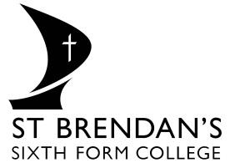

St Brendan’s Sixth Form College – Pre-enrolment Task
In order to give you a brief introduction to OCR Level 3 Technicals Business course and an indication of what it will be like to study this course for the next two years we would like you to complete a pre-enrolment task. The details are as shown below:
Subject: OCR Level 3 Business
What it I need further help? Please do not be concerned if you are unable to answer all questions or have queries you would like answered. If you would like further assistance during the summer period please email info@stbrn.ac.uk stating clearly the subject and your query. You are also welcome to ask subject teachers for help during the enrolment process
When should the task be submitted?
The task needs to be submitted during the first lesson in college
Task Details:
Each student must research the following key terms and write your own definition with an example. When students start the course they will have a test on the key terms.
In what format should the task be submitted?
In Microsoft Word – you will be shown how to upload the work onto the college Virtual Learning Environment – Moodle.
Your work should be checked for spelling/grammatical errors and must include your name

Before the first lesson all students must write their own definitions for all the following key terms with an example.

Limited liability

Market growth

Market research

Market segmentation

Market share

Niche market

Primary research

Profit

Qualitative research

Quantitative research

Revenue

Public Limited Company

Limited Company

Unlimited liability

Unique Selling Point

Secondary Research

