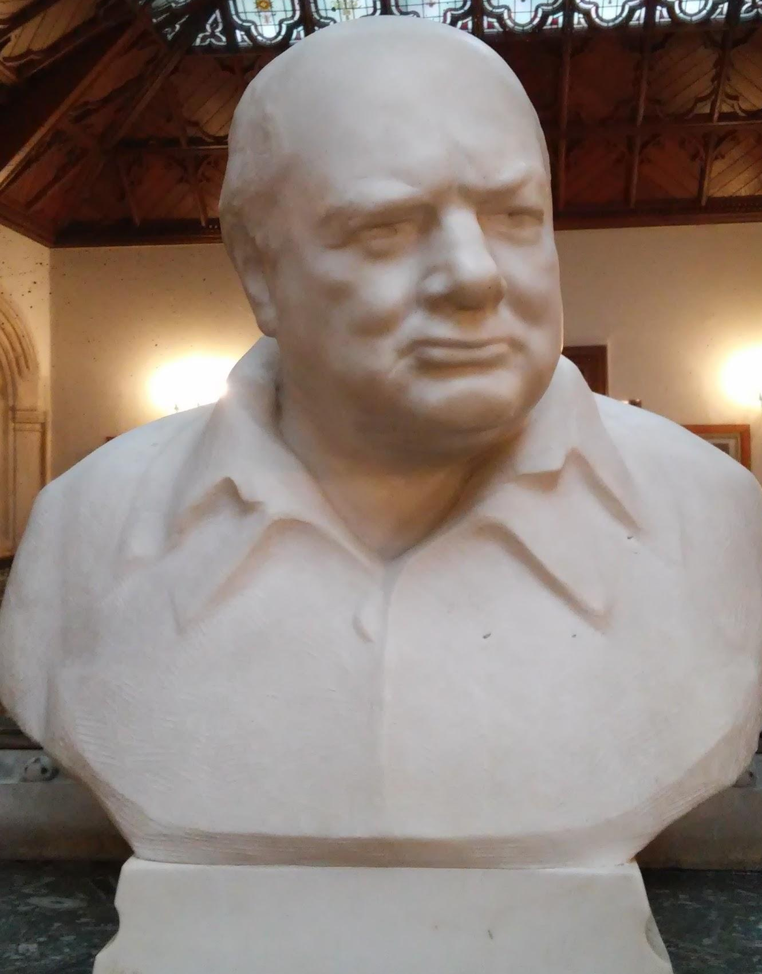
On the 12th of February 2015, our college followed up the plans to take maths and computing students to Bletchley Park in Milton Keynes. A huge estate that had been used as a site for cracking the German Ciphers in World War 2, utilizing the brightest minds that Britain had to offer at the time.

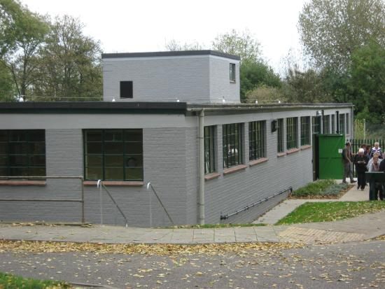
Our plan was to leave college at 7:30 and drive to Milton Keynes on a coach for approximately 3 hours, during which time I managed to get some more sleep somehow (the seats on the coach were really uncomfortable). At last, we arrived, greeted by newly refurbished grey walls of ‘Block C’ where we stayed for about 10 minutes whilst being introduced to their ‘electronic guides’ which we were given one per student. Those guides were in actuality ipods with special casing which disabled the access to the ‘home’ button’ and were stuck on the Bletchley app that was installed on them - if you ask me - considering the history of the place, that’s not very impressive, I would have thought they would implement something more inventive, but this is just a personal opinion, the guide itself was pretty helpful to be honest.

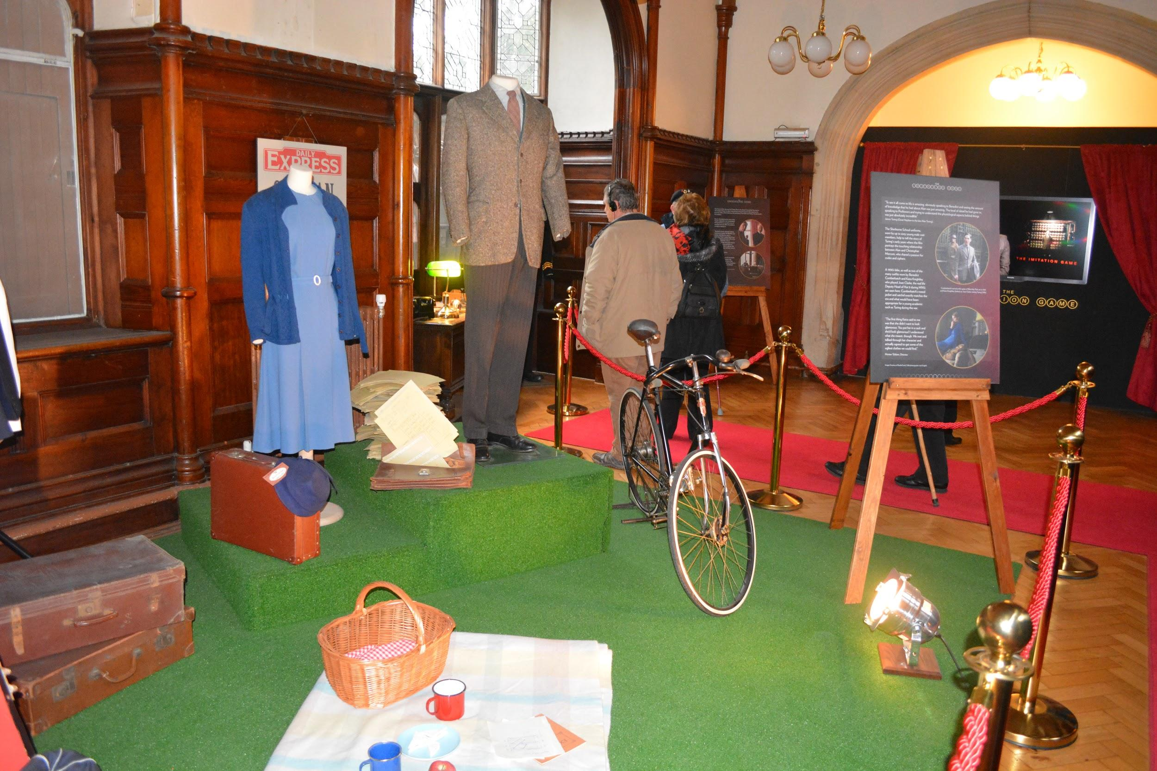
After the initial introductions, we were allowed to roam freely around the estate. I was instantly drawn to the Polish Memorial out of interest and being Polish myself, it was a good thing to see, however the schedule was tight so my friend and I moved on quick. We wandered inside the main mansion which had been used in the film ‘Imitation Game’ we got to see authentic props used in the movie - this was fairly interesting but, again, we had to move on due to having to meet up in front of the main mansion with the rest of the group at 12am for a tour of the park.

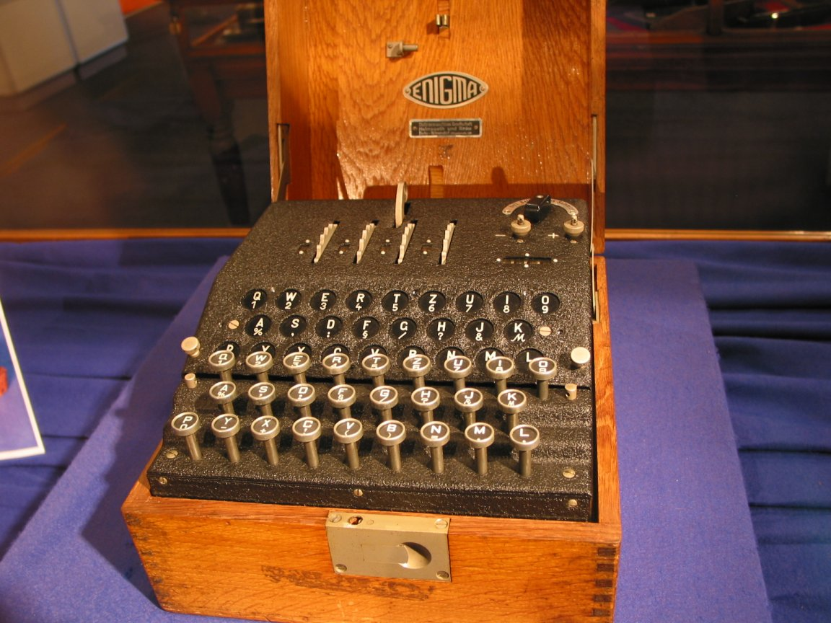
The group made it just in time for the tour. The man giving it could not have done a better job, he explained many things to do with the history of the estate and what went on there, whilst also being very funny and making the group laugh on multiple occasions.
One of the things we learnt was of the machine that Nazis used in WW2 to encrypt the messages they sent to each other the enigma cipher had an unreal number of combinations, the way Germans used it, there was 150,000,000,000,000,000,000 possible combinations but the number of theoretical combinations had dwarfed this figure, with over $3×{10}^{114}$(3 with 114 zeros after it) meant that this machine had more possible states than there are atoms in the universe - so far so good. After the tour of all the places, which we had time for, it was indeed time to move onto the National Museum of Computing.

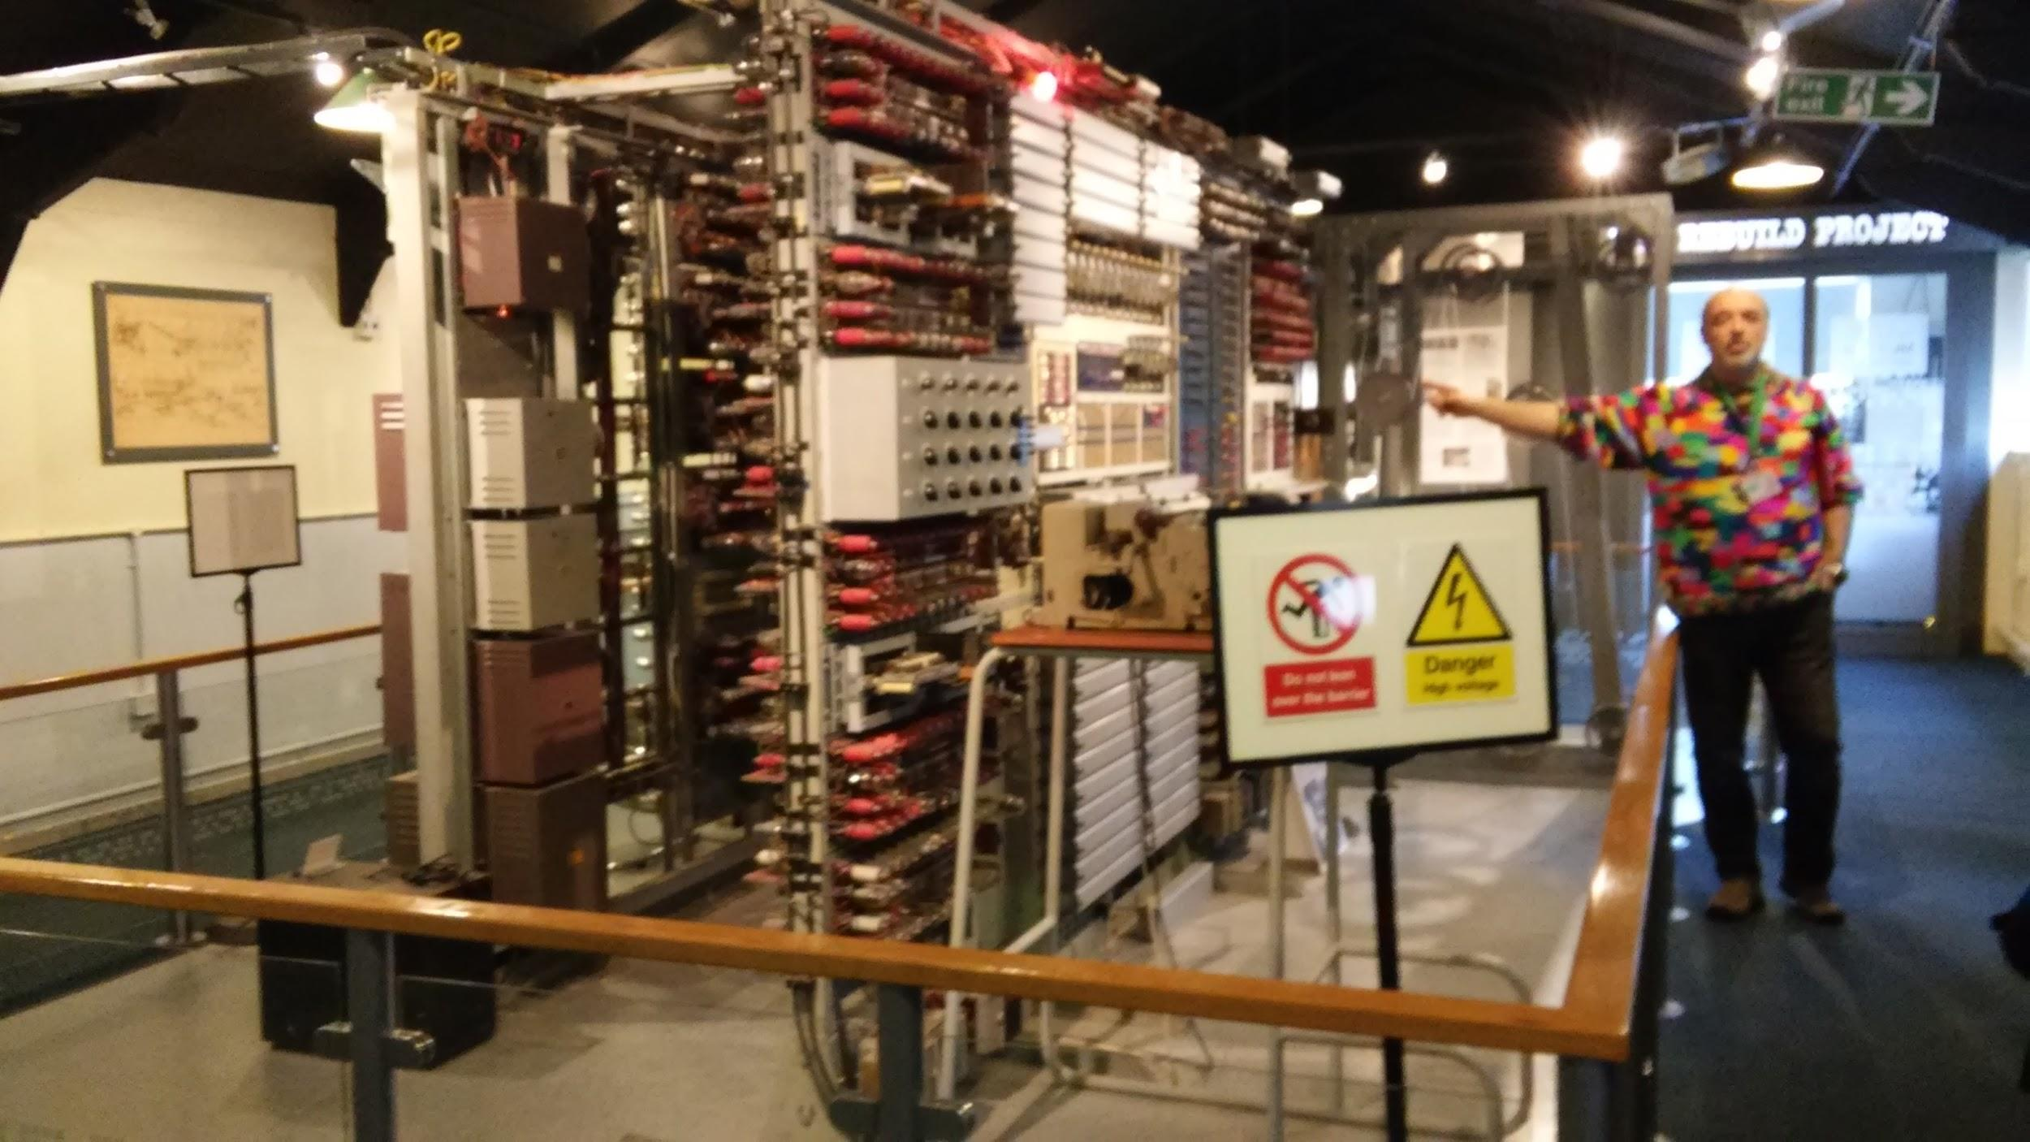
Here is where it gets interesting (for me at least). In the museum, we were greeted by Chris Monk who is the head of the educational department, he took us to a presentation room where he used a Power-point to explain exactly what the museum was all about and how it got there (spoilers: it was about computers). After the presentation we were guided to the WITCH, the world’s oldest working computer. We were shown how it worked in detail. This was an interesting experience, it really emphasised how much we’ve progressed since the WITCH is the size of an average bedroom and had the equivalent memory of about 3Kb, and the computing power scaled accordingly. Next we were given almost a complete tour of the museum, all history of computers, including the rebuild of the world’s first computer - “The Collossus”.
Unfortunately I only have space to talk about these two biggest ‘exhibits’ in this article but I definitely recommend the place.

We made our way back at 4:30pm where a 3 hour journey back awaited us. After we came back it was dark and we all made our separate ways home. Overall, the journey was very enjoyable, considering it included a year’s pass to Bletchley Estate- definitely worth the £35. Personally, I preferred the Computing museum to Bletchley Park but that’s opinion, I definitely recommend it to anyone who is thinking about taking up A level Computing or Maths.

Article by Milosz Calus

