**How to access your Universal Credit Statement**

Go to <https://www.universal-credit.service.gov.uk/start>

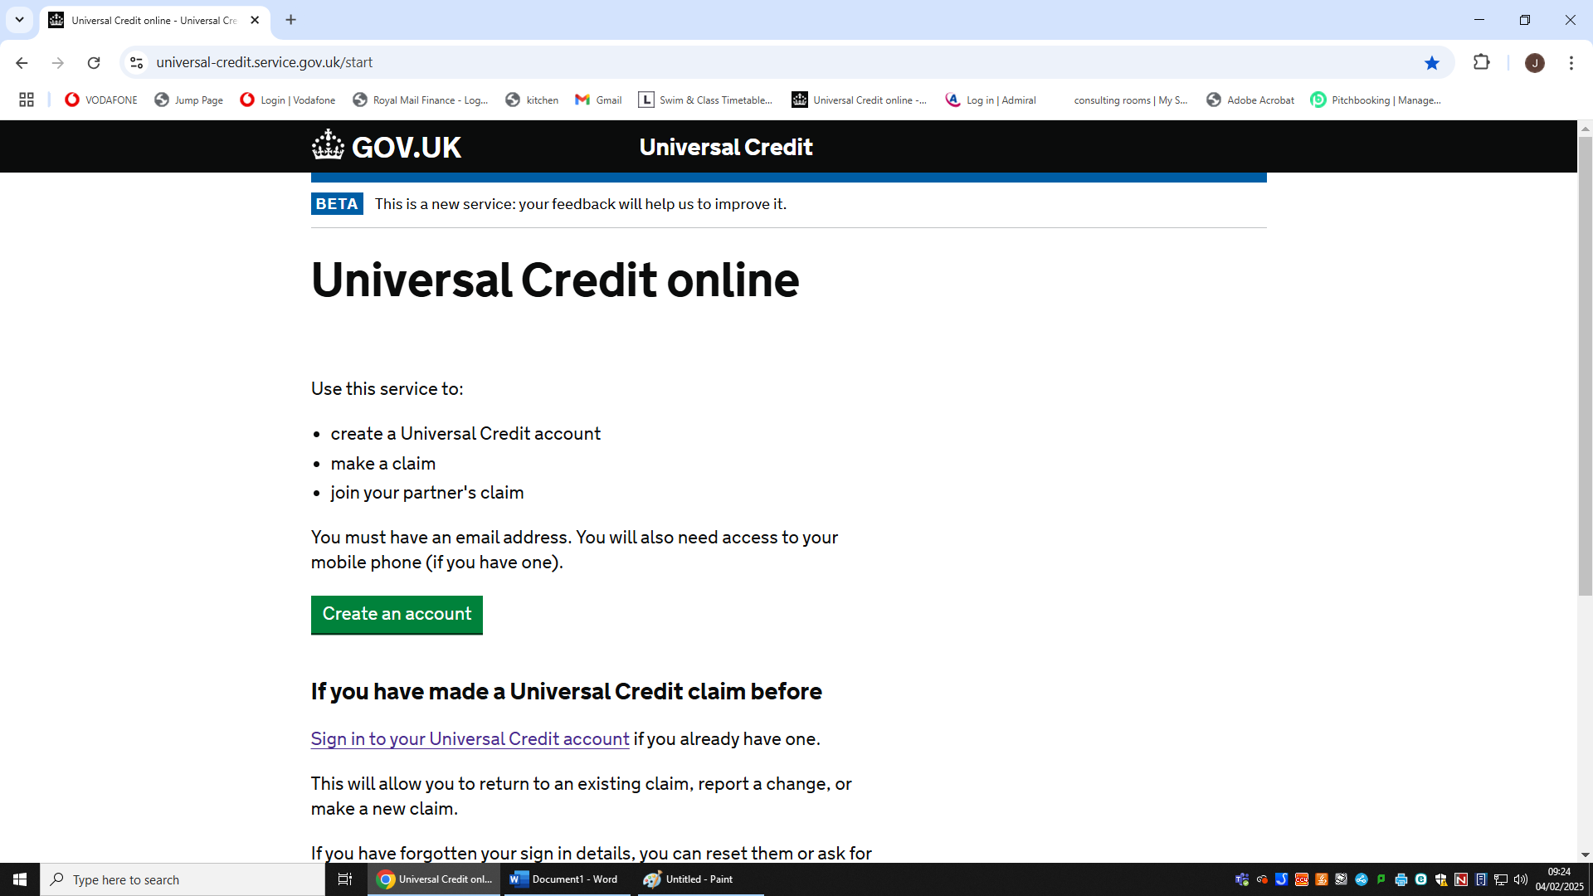Click ‘Sign in to your Universal Credit Account’

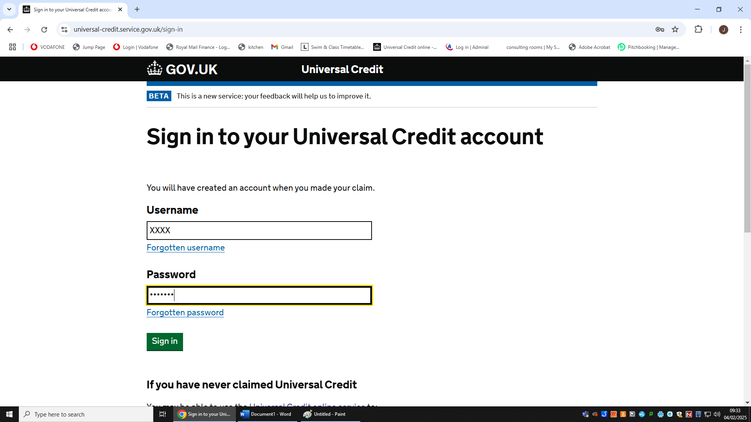Enter your Username and Password

Then click Sign in

They may send you a text or email with a code, enter this and click ‘Continue’.

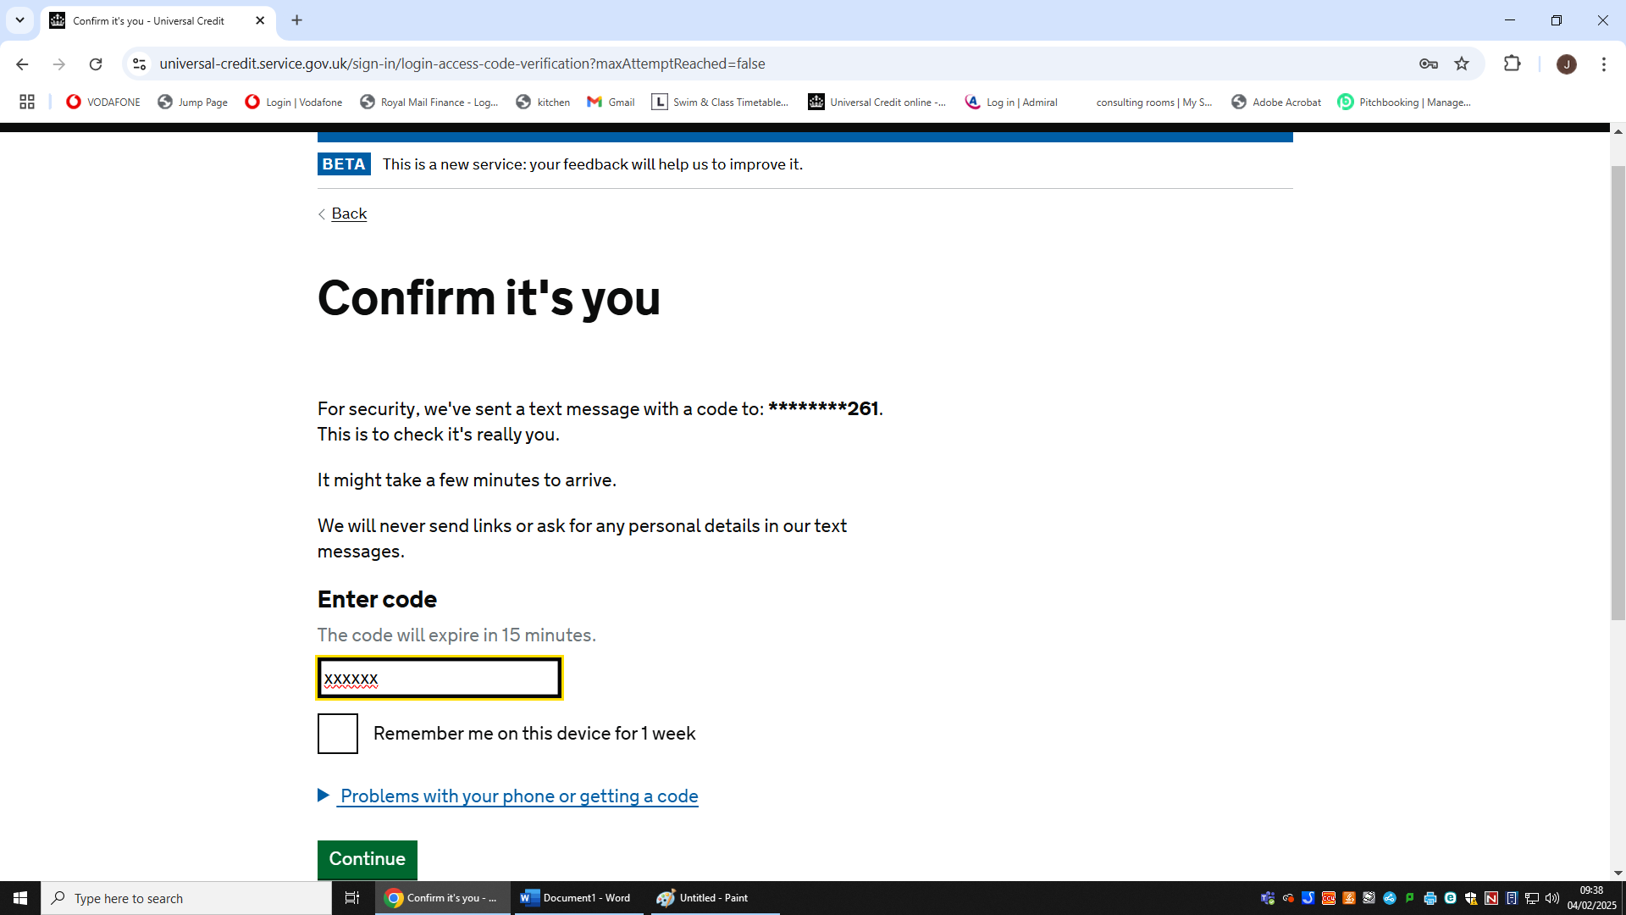

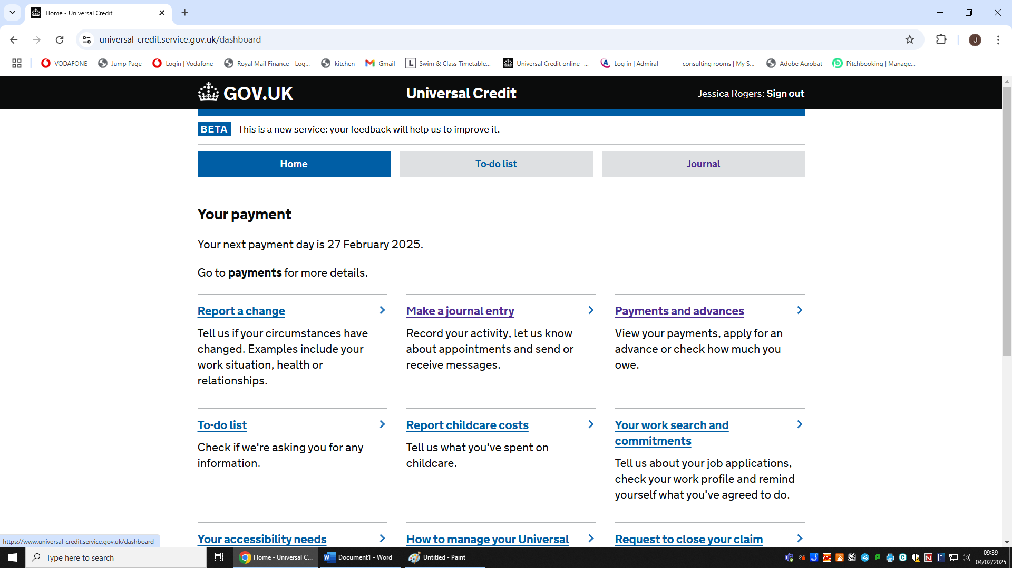Click ‘Home’ then click ‘Payments and advances’

Then click ‘Payments’

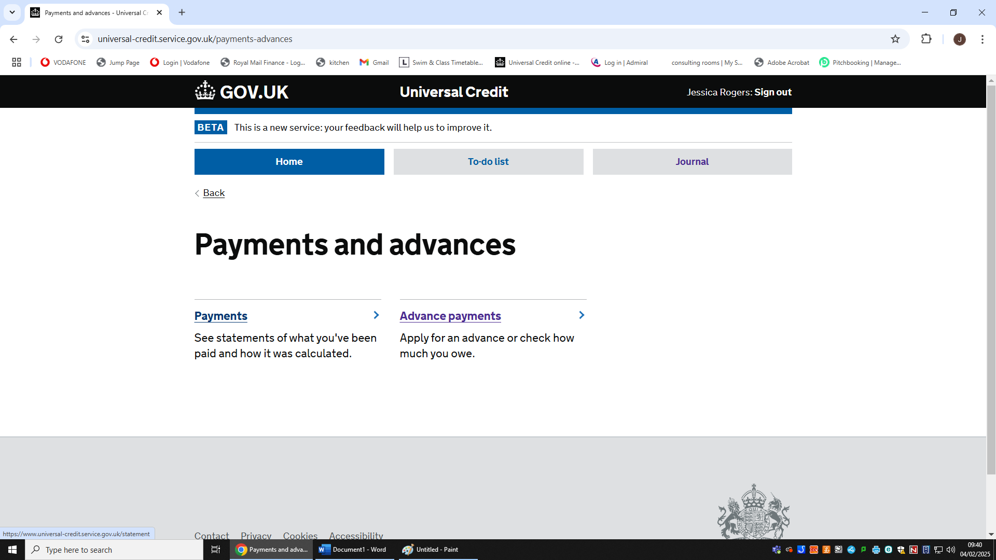

This will show you a list of your Statements

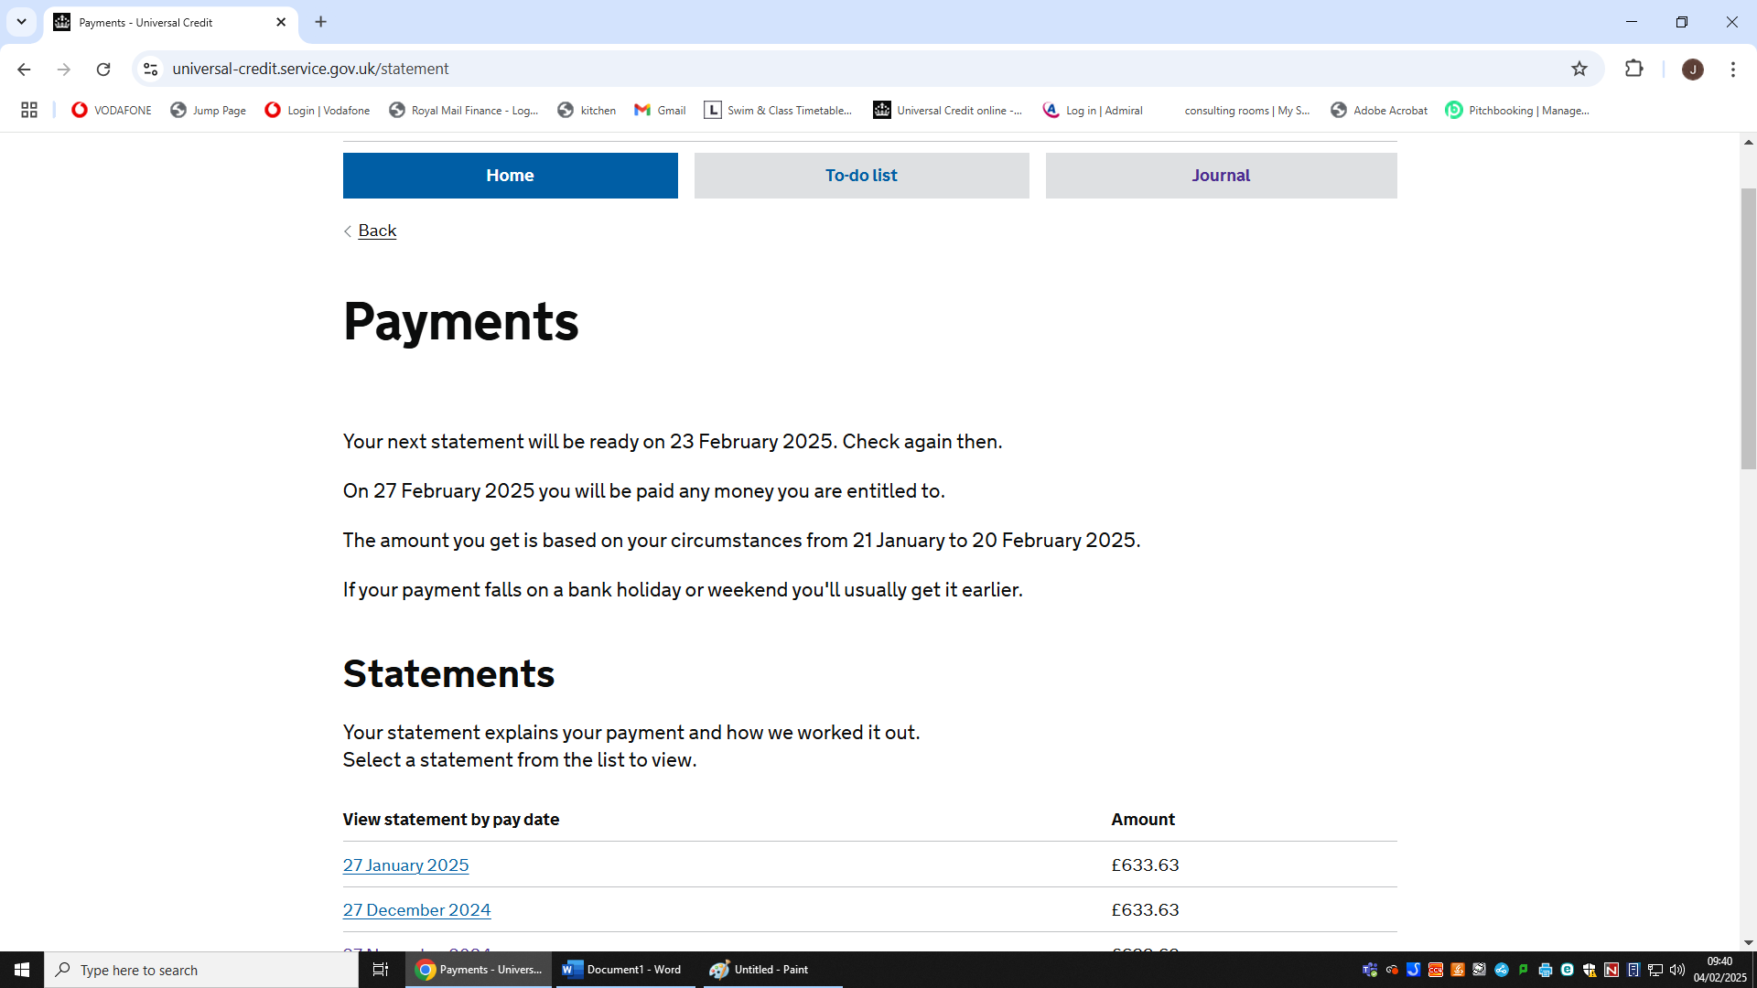Click on one of the Statements

This will show you one of your Statements, you can either take screen shots of all pages of the statement and upload them onto PayMyStudent

or you can Click ‘Print this statement’ save as a PDF and upload it to PayMyStudent.

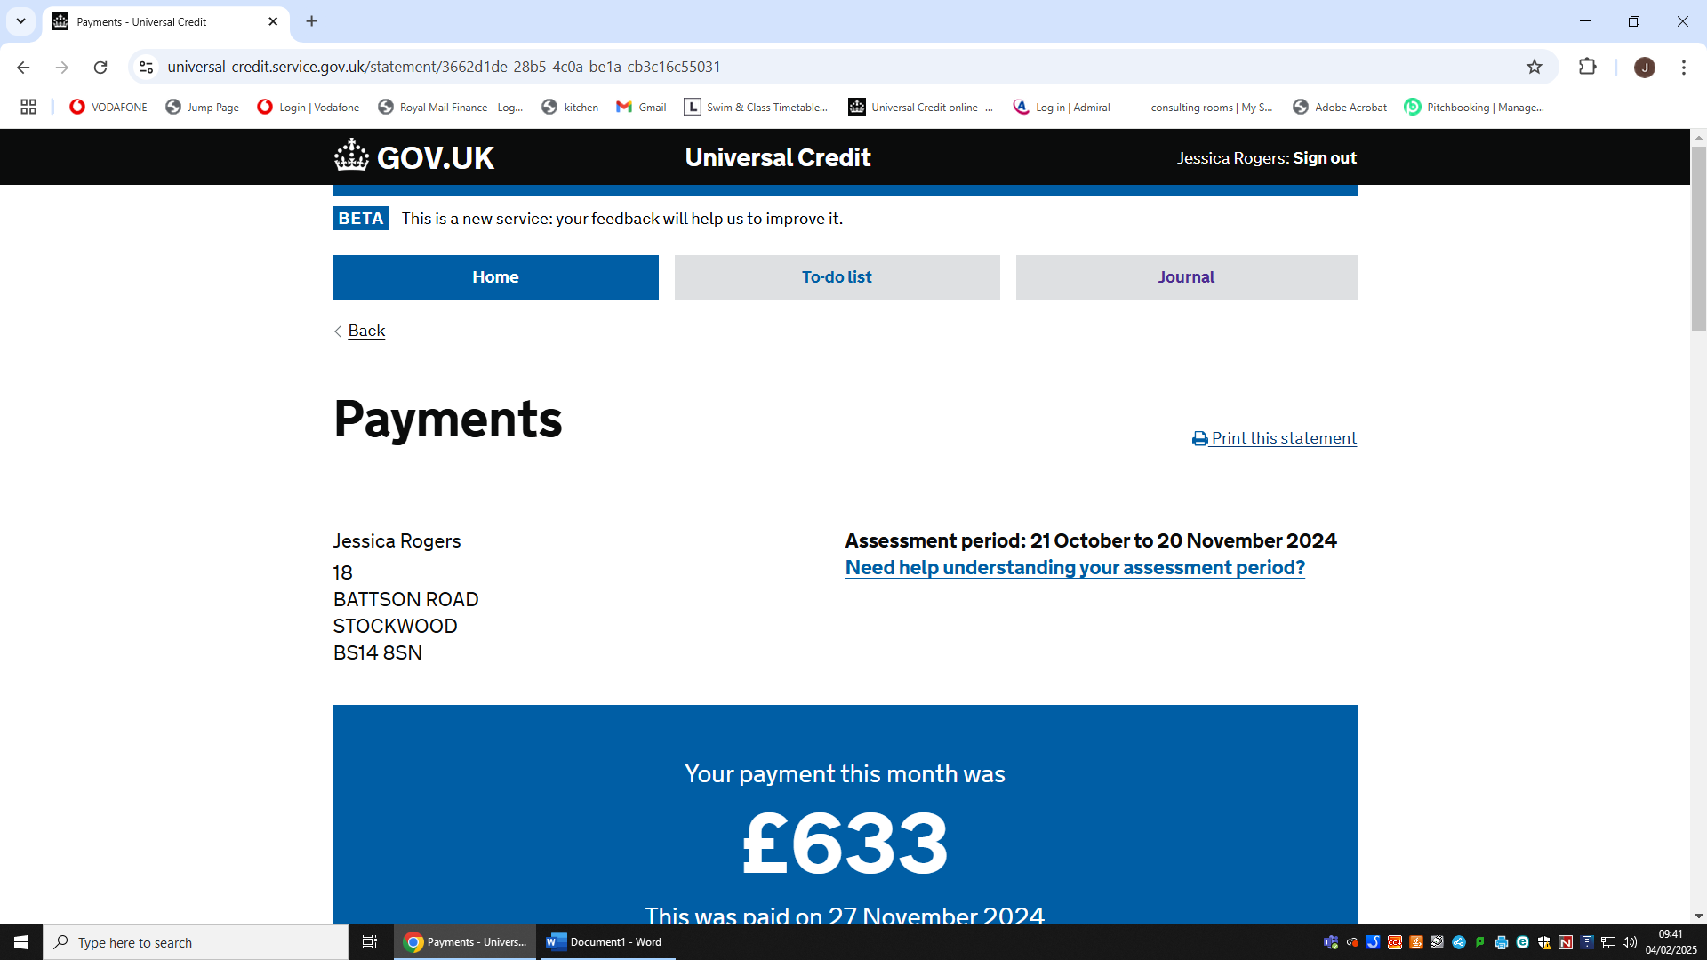

**Make sure you do this for the previous 3 statements.**

Joe Smith

Cherry lane

CN11 811

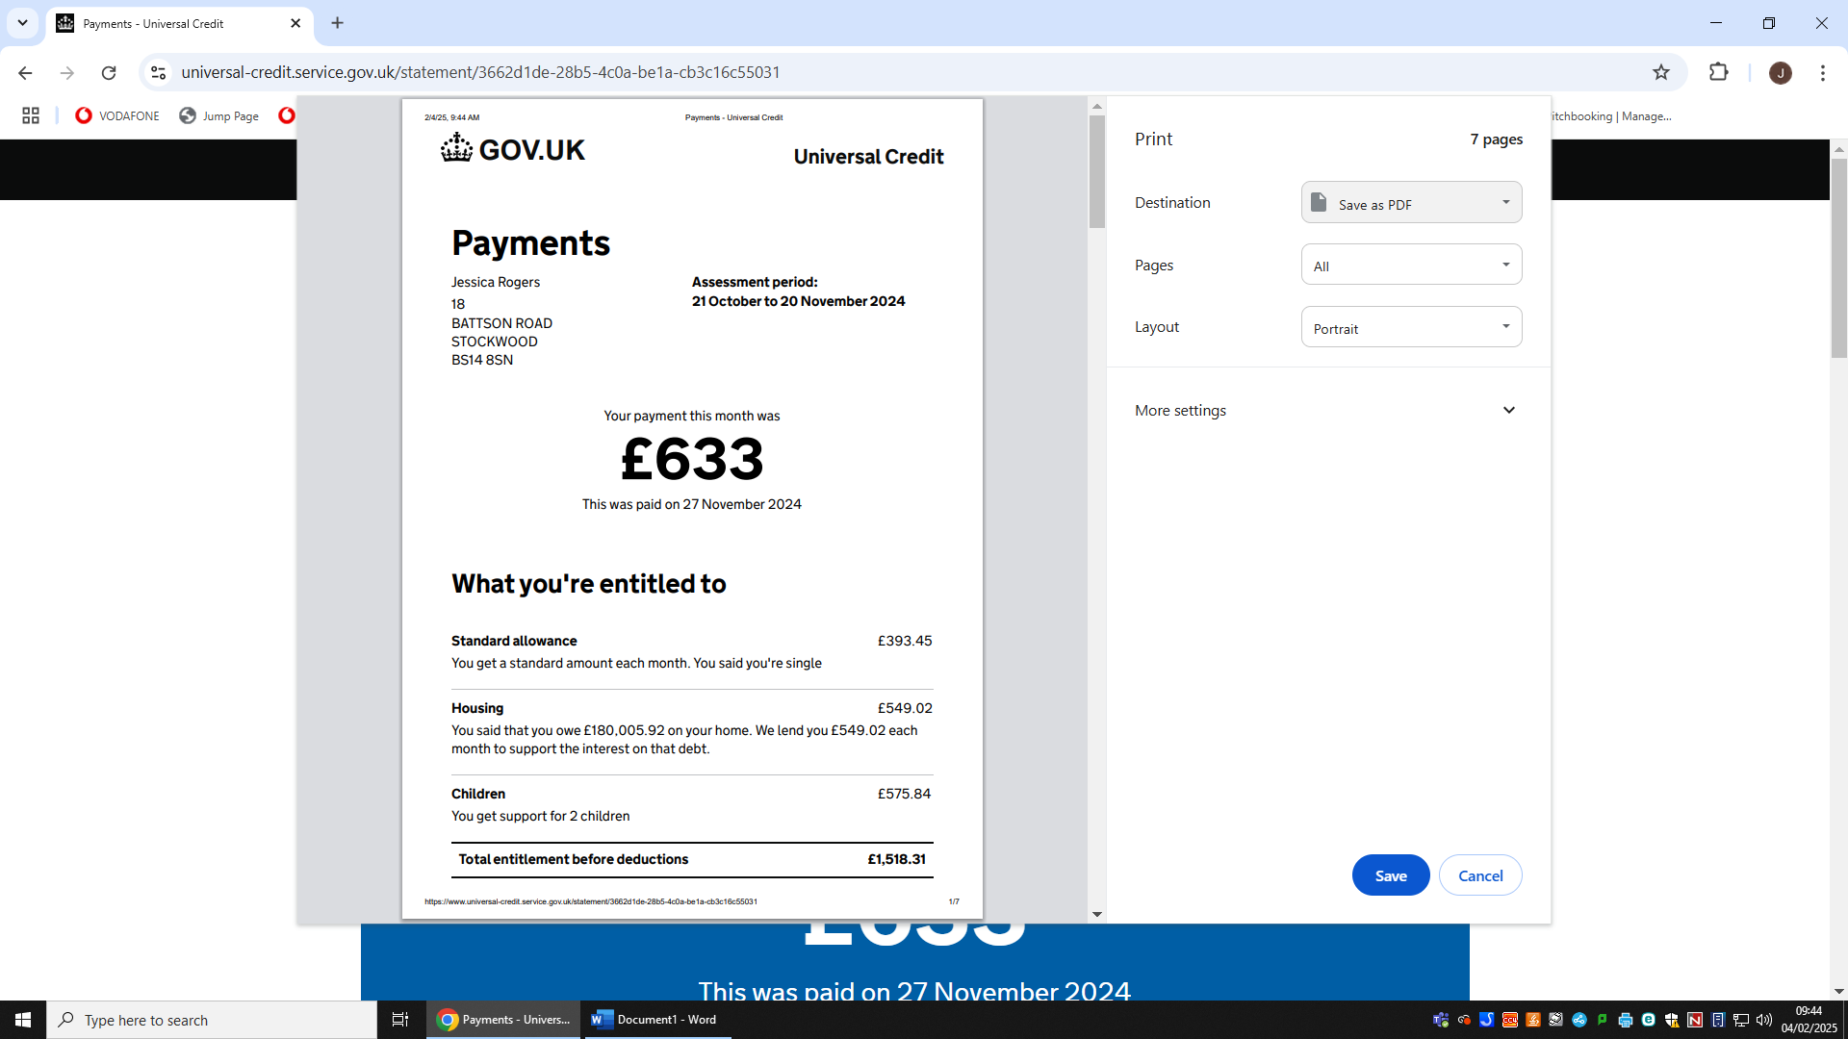Saving statement as a PDF

Joe Smith

Cherry lane

CN11 811