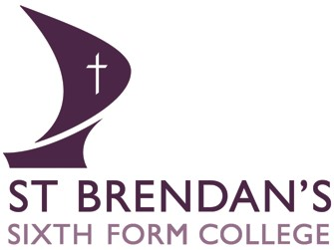
Mission Statement
Faith in learning
St Brendan’s mission is to serve the Catholic and wider community by providing Sixth Form education of the highest quality and to act in the spirit of the Gospel believing that every person is loved by God and has a unique value.

